**Asset Tracking System**

For

Manarat International University

**Basic Features:**

* Super Admin, Co Admin & User Privilege Policies
* Working Capacities / Abilities with Web Platform

**Project Description:**

This system is for asset management and tracking for Manarat International university(MIU). MIU has various branches (Ashulia and Gulsan-02) which it distributes various assets (Table, Chair, Desktop, Laptop, Server etc.) also MU has to manage its own asset and MIU organizes various events regarding which Manarat has to purchase assets.

**\*\*\* Please keep in note that every setup page should have a search and edit page for searching against criteria of the records and editing a particular record. \*\*\***

**\*\*\* Every drop-down should have typing option and it must provide suggestion about the loaded data when typing. \*\*\***

**\*\*\* All Name and Short Name are MANDATORY. All Short Name length max 5 (Five) digit long and Short Name will be unique* (based on) and alphabetic in capital letter, there should not be any space in short name letter. \*\*\***

**Modules:**

# 1. Organization Setup (See the Mock)

In this setup page user will setup organization, Name, Short Name, Location, Description.

* Short name will be unique by organization.
* Location and Descriptions are optional.

After saving the information, organization Information will be displayed as a summary information.

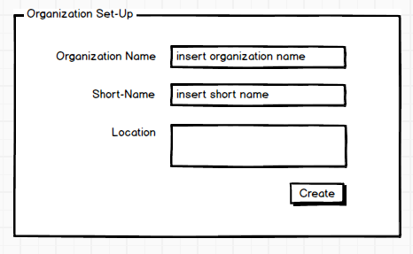

# 2. Organization Branch Setup (See the Mock)

In this setup page user will setup Branch for organization, where user will select organization from dropdown list and provide branch name, short name.

* Short Name will be unique by organization.
* Branch code will be generated automatically with <OrganizationShortName>_<BranchShortName>, i.e. MIU_ASH, MIU_GUL.

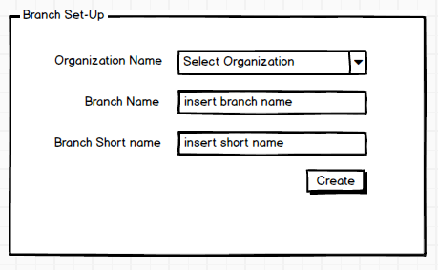

# 3. Asset Location Setup (See the Mock)

In this Page user will provide asset location configuration by Organization Branch.

In this setup page Asset Location should be entered by providing organization, and organization’s branch. Location information will be considered with Location Name, Short Name

* Short Name is unique By Organization and Branch.
* Location Code will be displayed as <BranchCode>_<Location ShortName> i.e. MIU_ASH_A001, MIU_GUL_S001.

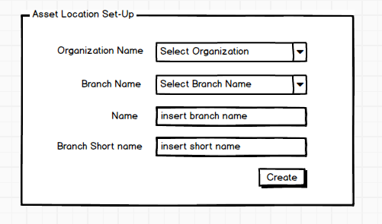

# 4. Asset Type Setup (See the Mock)

In this setup page user will setup Asset Type for Asset Group (Next Setup), where user will provide Name, Short Name, and Code.

● Code will be generated automatically with <ShortName>, i.e. ELCTX_000001, ELCTC_000001, FURNT_000001, etc

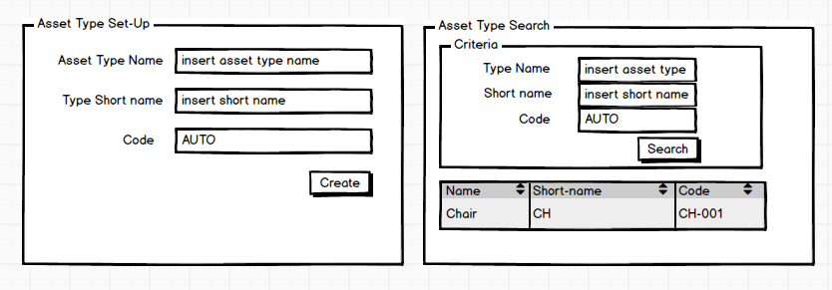

# 5. Asset Group Setup

In this setup page user will setup Asset Group for Asset Manufacturer (Next Setup), where user will select Asset Type from dropdown list and provide Name, Short Name, and Code.

• Type, Name, Short Name fields are mandatory.

* Short Name will be unique By Asset Type.
* Code will be generated automatically with <ShortName>, i.e. LAPTP_000001, PRNTR_000001, DSKTP_000001, etc

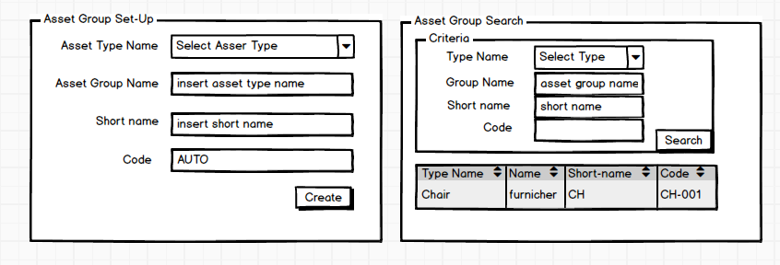

# 6. Asset Manufacturer Setup

In this setup page user will setup Asset Manufacturer for Asset Entry (Next Setup), where user will select Asset Group from dropdown list and provide Name, Short Name, Code and Description (Optional).

* Short Name will be unique By Asset Group.
* Code will be generating automatically with <ShortName>, i.e. HP_000001, SAMSG_000001, DELL_000001, etc

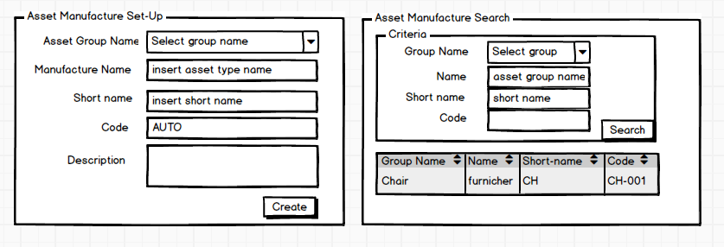

# 7. Asset Model Setup

In this setup page user will setup Asset Model for Asset Entry (Next Setup), where user will select Asset Group and Asset Manufacturer from dropdown list and provide Name, Short Name, Code and Description (Optional).

• Manufacturer, Group, Name, Short Name fields are mandatory.

* Short Name will be unique By Asset Group and Manufacturer.
* Code will be generating automatically with <ShortName>, i.e. PAVLN_000001, PROBK_000001 etc

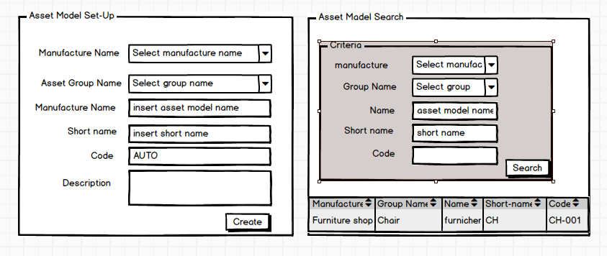

# 8. Employee Setup

In this setup page user will setup Employee for Asset, where user will select Organization and Branch from dropdown list and provide First Name, Last Name, Contact No, Email, Address, Picture (Opt) Code (Auto).

* Contact Number will be unique.
* Code will be generating automatically with E.g. First Name: Arman Malik, Last Name: Chowdhury <First Name (3 digit) Last Name (2 digit)>, i.e. ARMCH_000001 etc

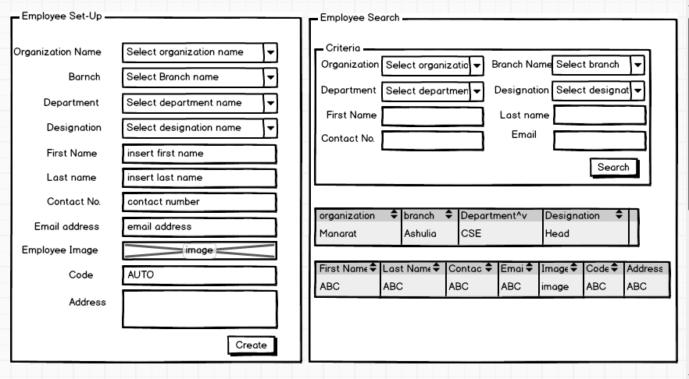

# 9. Vendor Setup

In this setup page user will setup Vendor for Asset Operation Where user will Provide Name, Short Name and Code,

• Name, Short Name, Contact No fields are mandatory.

● Code will be generating automatically with

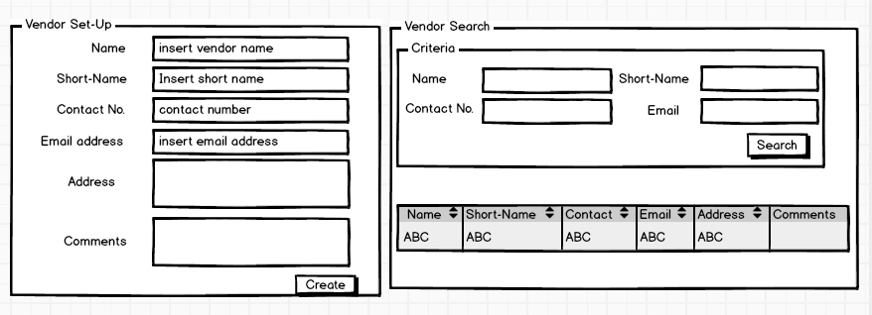

# Operation Module

## 1. Asset Entry/ Asset Registration (See the MOCK)

In this page user will Entry/ register [unregistered/ New] Asset. After completed this operation Asset ID will Auto generated. Asset ID format would be [Asset Type Name (1)] [Asset Group Name (1)] [Asset Model Name (3)] [6 digit numeric] example, CLPRO000001 - [Computer] [Laptop] [ProBook] [000001]

After Save, it will redirect to Asset Edit Page, if user want to add more information, so user can add easily from this page. There has a file input system.

** All Dropdown, Name and Serial No fields are Mandatory. **

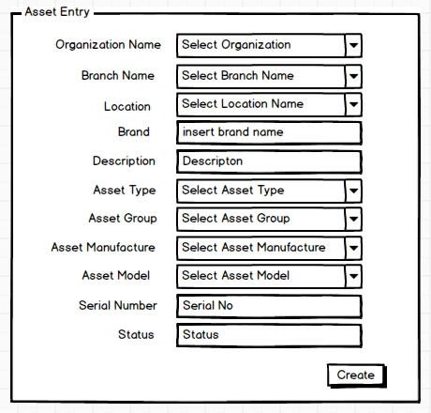

## 2. Asset Edit (See the MOCK)

In Edit Page, You Can see multiple TAB section in the bellow of edit page, and those tabs are Finance, Service, Attachment, Notes, History etc, and multi types of operation can do from here.

**Finance Tab:** This tab contains Finance related information field for this Asset. See the Mock, every (*) field is required.

**Service/ Repairing Tab:** This tab contains Service or Repairing related information field for this Asset. See the Mock, every (*) field is required.

**Attachment Tab:** In this tab, user can add any attachment for this asset, if user want to add any document for this asset, then can do from here, and this tab not mandatory, but if u want to save this tab, then you must provide any Document file/ Attachment.

**Notes Tab:** In this Tab, User can add some comment or some extra description or any kind of text message for this asset, and this tab not mandatory, but if u want to save this tab, then you must provide any note.

**History Tab:** From the Asset Entry tracking record will add for All kinds of operation against the Asset, and this history tab’s show those tracking history.

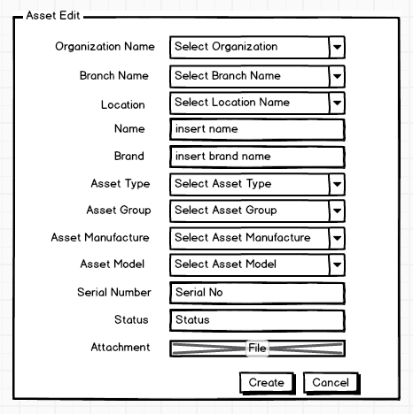

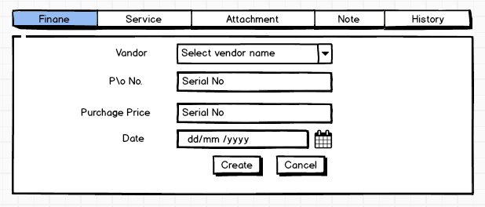

**3. Check Out (See the MOCK):**

In this page, user can Move/ Distribute any single/ Multiple Asset to the particular Employee.

User provide Employee No, Select Employee, Entry Date (Check out Date), Due Date (Return Date), Select Check out for and Location. In the location dropdown, if location not found in the dropdown then you can see a search button (right side of the location Dropdown), If user click the button, then a pop up modal will show (See the Mock) and user can select any location by filtering. All (*) field are mandatory.

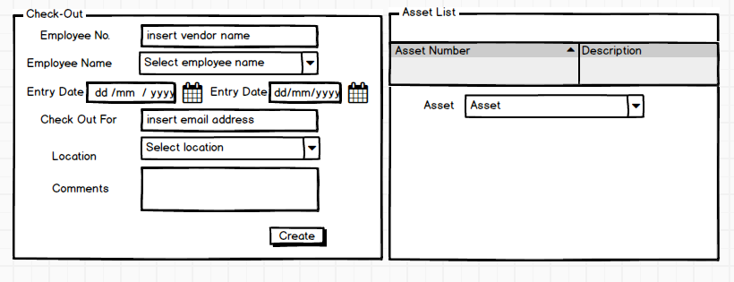

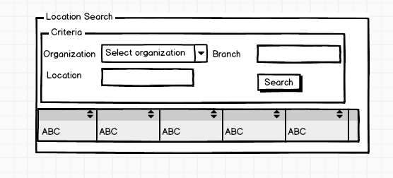

**Check In (See the MOCK):**

In this page, you can see all checked out Asset list and user can Check in All Asset By checked on checkboxes then select the check in status from dropdown and select location from dropdown/ searching (from pop up), comment, (**) finally click complete check in button.

** Print Check in receipt check box: If user checked the check box, provide the receipt for print.

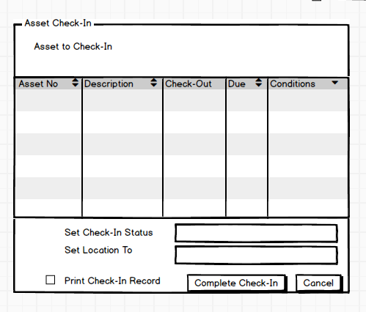

**Asset Audit (See the MOCK):**

In this page, user can audit against any particular Asset or Multiple Asset, for that all Asset are loaded in the table and have a button (see the Mock) in every row. If user want to audit particular Asset, click the action button (right side of the row), it will provide a pop up modal (see the Mock), provide that information and finally save.

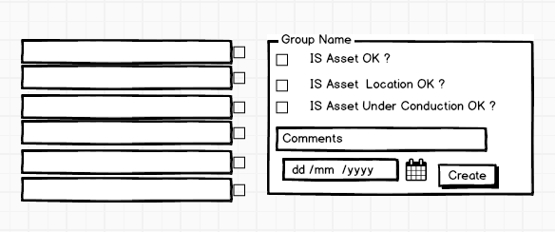

**Dashboard (See The MOCK):**

In this page have 4 (four) section (see the Mock),

1. Load all Assets
2. Checked in Due List.
3. Checked out list.
4. Asset Activity (Every Assets Tracking load on this section).

